**Question 1. Familiar with Git commands like git init, git status, git add, git commit, git push, and git pull.**

**OUTPUT:**

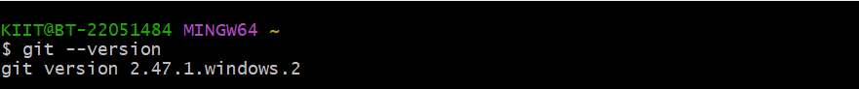





**Question 2. Implement git ignore command to ignore unwanted files and folders**

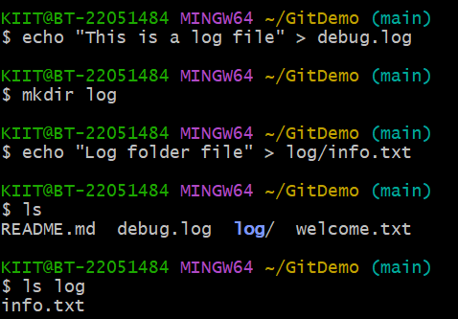**OUTPUT:**

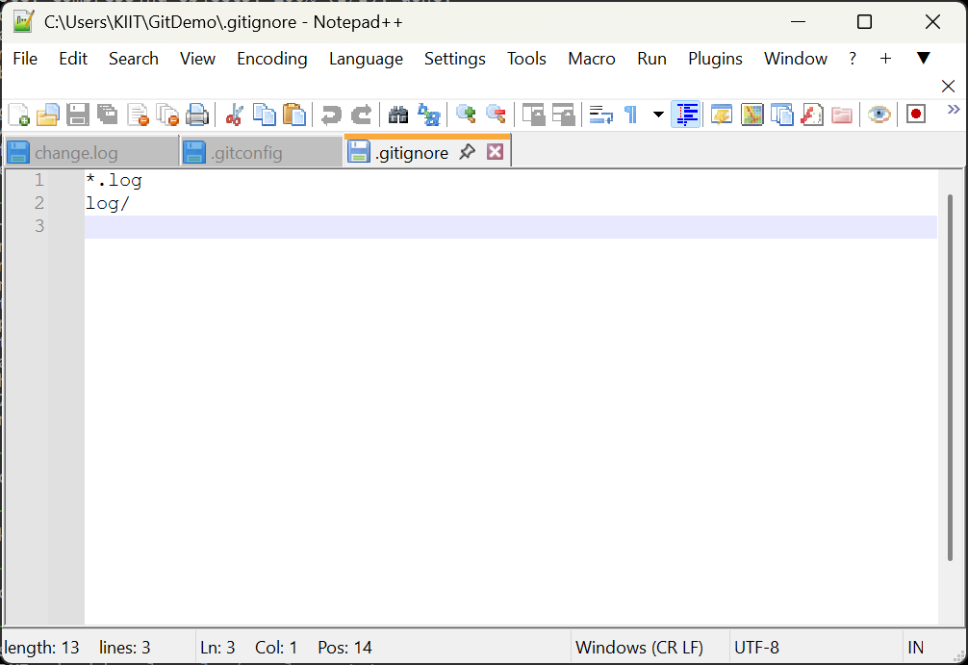

**Question 3. Construct a branch, do some changes in the branch, and merge it with master (or trunk)**

**OUTPUT:**

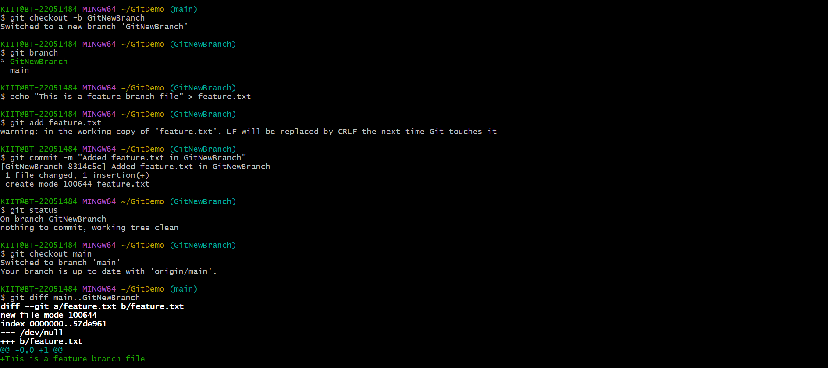

**Question 4. Implement conflict resolution when multiple users are updating the trunk (or master) in such a way that it results into a conflict with the branch’s modification.**

**OUTPUT:**

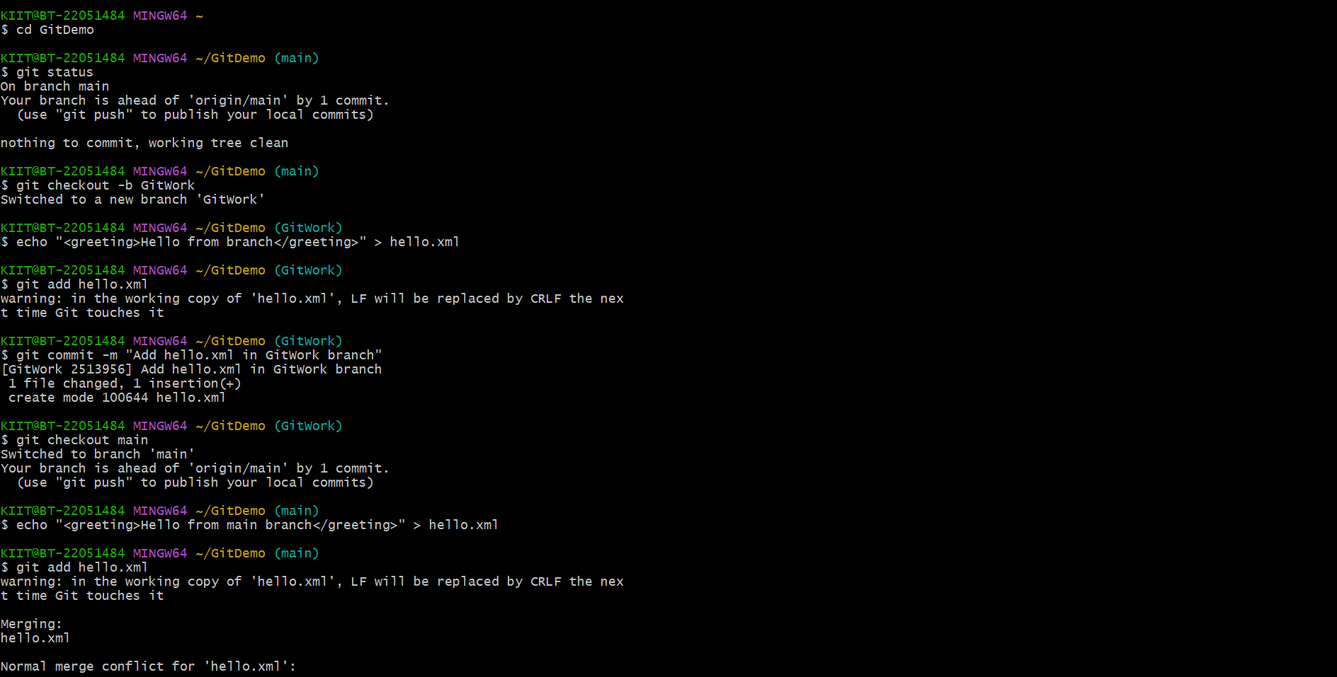

**Question 5. Execute steps involving clean up and push back to remote Git.**

**OUTPUT:**

